Jesus enters Jerusalem – Palm leaf activity

In this activity you will need:
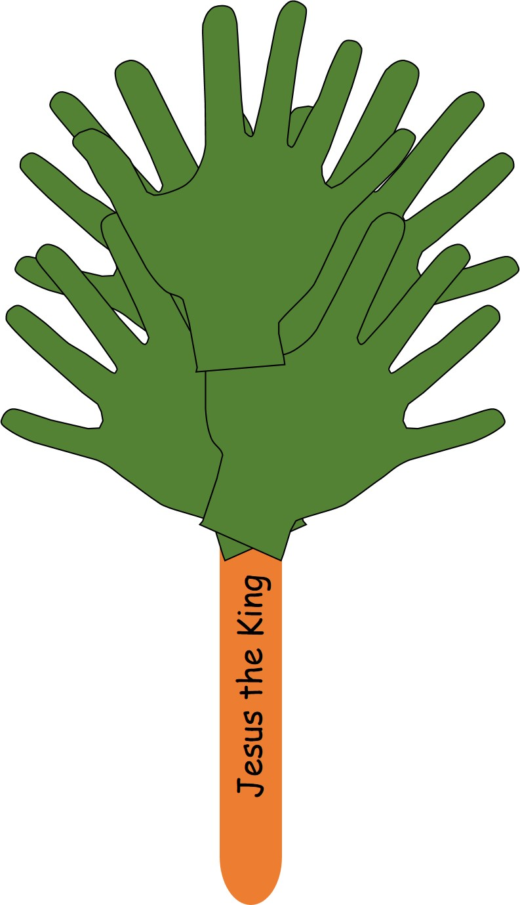
- Your hand
- A pencil
- Some paper (green would be best)
- Some coloured crayons or pens
- A craft stick (a clean lolly stick will do)
- Some paper glue
- A pair of scissors
- A clever mum or dad to help you with the cutting out and to adapt the instructions if you haven’t all the materials.
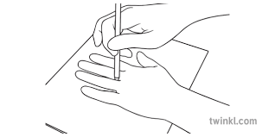

- Firstly draw around your hand on a piece of paper.
- Repeat this 4 times, so you have 5 hands.
- Next, if you have used white paper colour the hands with green pen or crayon.
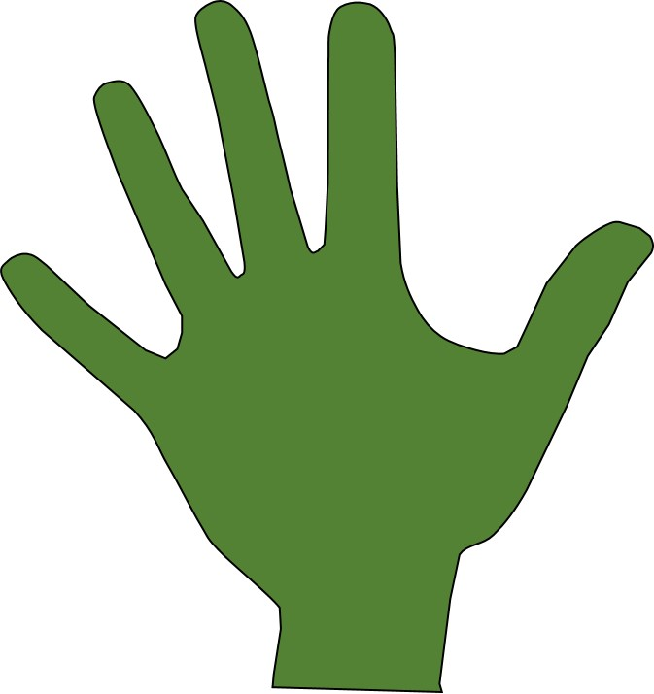
- Now cut out each of the hand, get mum or dad to help you if it is difficult.

- Stick one hand shape on top of another one like the picture.
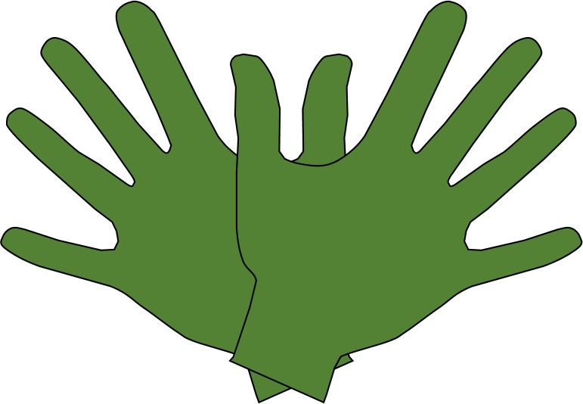
- Repeat this with 2 more hands.

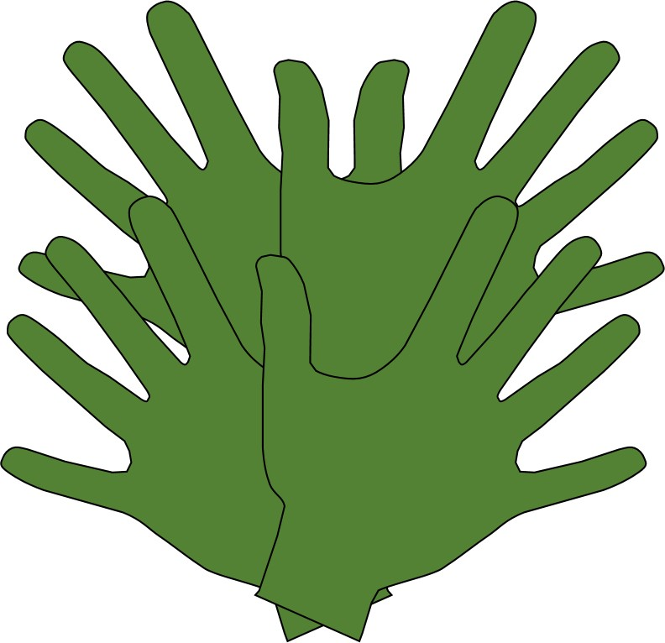

- Now carefully stick one pair of hands onto the other pair of hands.

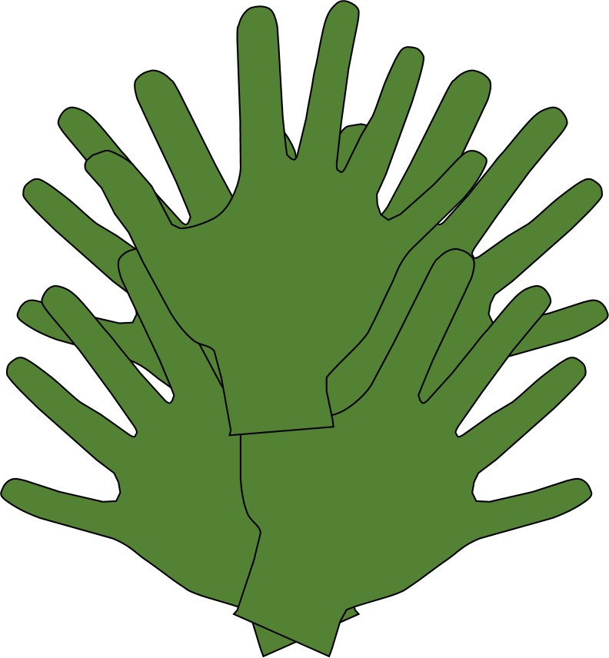
- Now stick the last hand shape onto the other hands.
- Finally stick your craft stick onto the bottom of your palm leaf hands to make a stem for the leaves.

- If you have space on the stick write “Jesus is King” to remind you that the people waved palm leaves to welcome Jesus the King.

