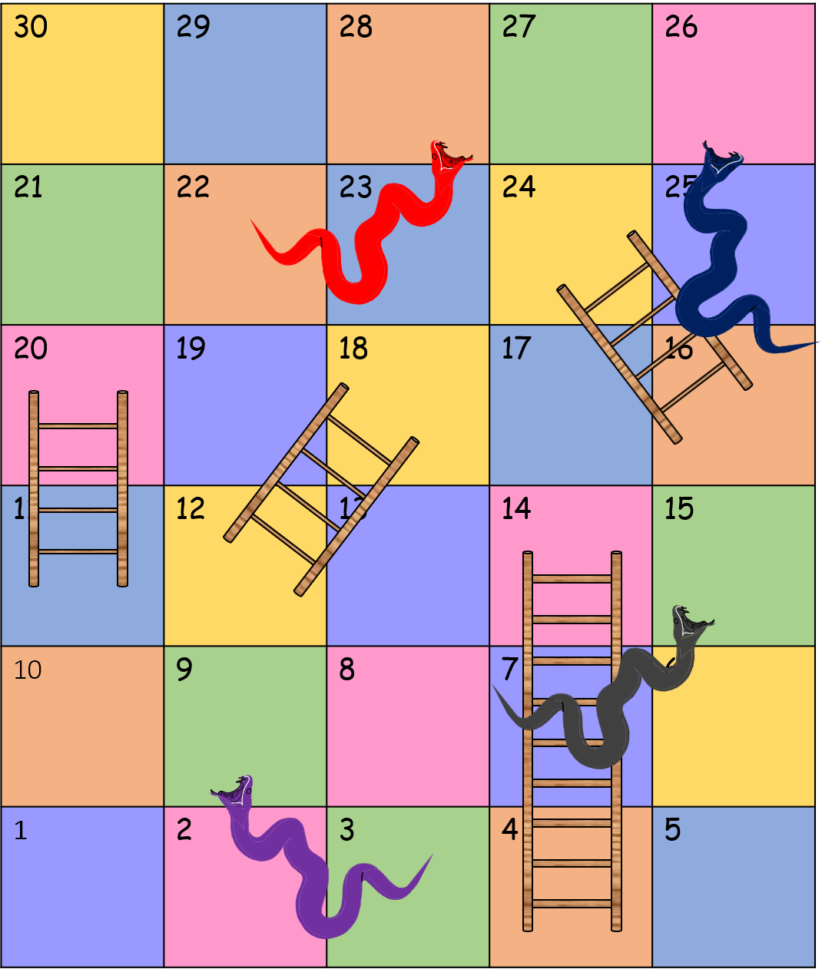

Moses and the 3rd Commandment Craft

You must not use the name of the Lord your God thoughtlessly. Exodus 20 v7

You will need:

* Snakes and Ladders Template
* A4 thin card or paper
* Colouring pens or pencils
* Six sided dice
* (Coloured) counters

1. Print the Snakes and Ladders template onto A4 paper or thin card.
2. Colour the squares and snakes
3. Now you are ready to play.

Rules for the game

1. Start at square 1. The youngest player rolls the dice first and moves the number on his throw.
2. If the player lands on a ladder and is able to say a word to describe God the player can go up the ladder. Otherwise stay where you are.
3. If the player lands on a snake mouth and is able to say a word to describe God then player stays where they are. Otherwise slide down the snake.
4. The first player to get to square 30 wins

