[Original image: https://www.pinterest.co.uk/pin/110971578291714382/](https://www.pinterest.co.uk/pin/110971578291714382/)

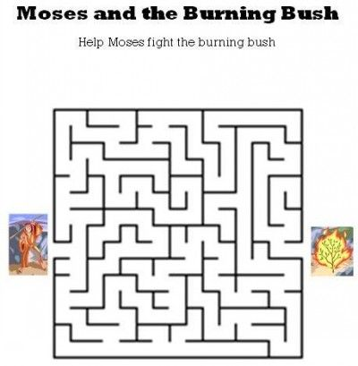

Help Moses find his way to the burning bush.