Moses and the Red Sea – Jigsaw Craft

In this activity you will need:
- A piece of thin A4 card
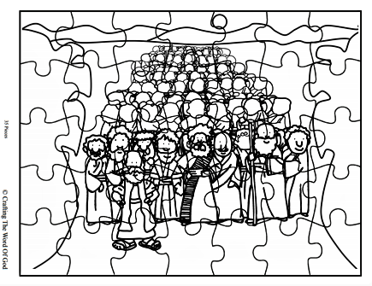
- Some coloured crayons or pens
- A printed copy of the jigsaw template
- A pair of scissors
- A clever mum or dad to help you with the cutting out and to adapt the instructions if you haven’t all the materials.

- Firstly, print out the template on page 2 onto thin card.

- Next, colour in the picture on the card.

- When you are happy with your colouring, carefully cut out the jigsaw shapes; you might need mum or dad to help you with this.

- You now have a jigsaw of the crossing of the Red Sea which you can complete or share with a friend.

