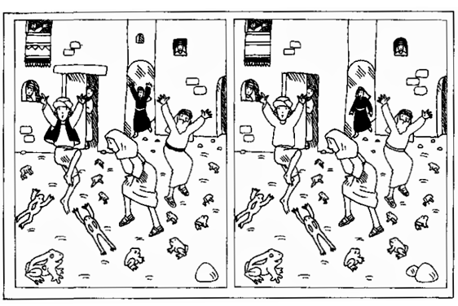

Moses and 10 plagues- Exodus 4-14

Can you find 10 differences in this plague of frogs, picture?

[Original image : http://purelove.jp/ucbooks/Sunday_School/1%20My%20Book%20of%20God/48)%20Ten%20Plagues-lesson.pdf](http://purelove.jp/ucbooks/Sunday_School/1%20My%20Book%20of%20God/48)%20Ten%20Plagues-lesson.pdf)