Easter Story – Prayer card craft activity

In this activity you will need:
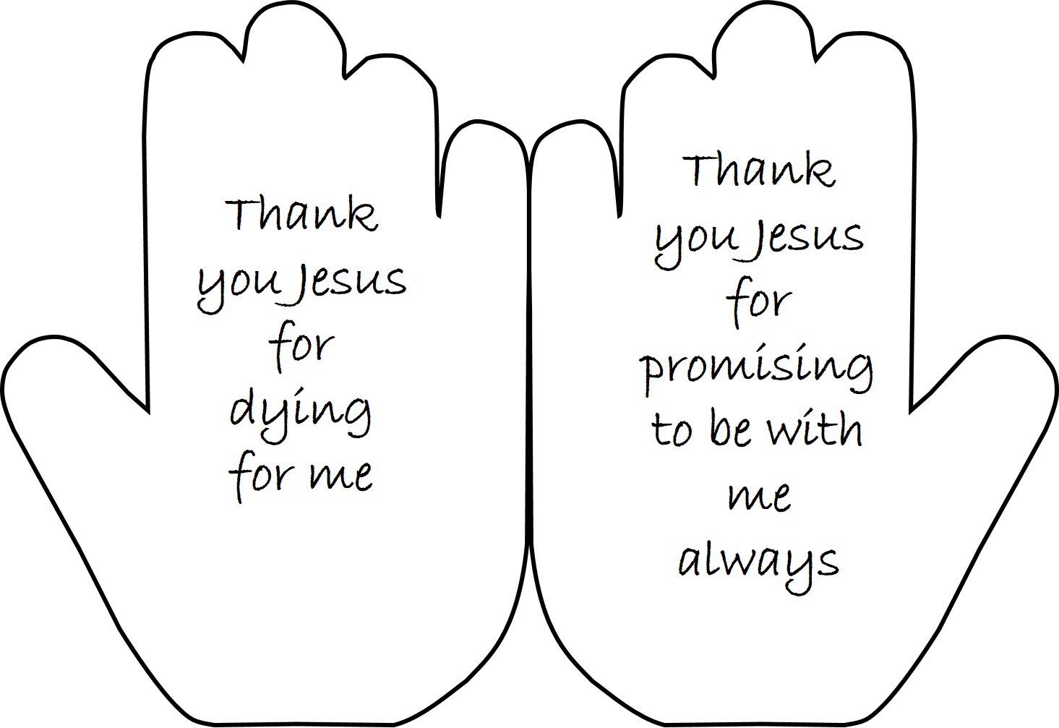
- Your hand
- A pencil
- Some A4 card
- A pair of scissors
- A clever mum or dad to help you with the cutting out and to adapt the instructions if you haven’t all the materials.

- Firstly, fold your A4 piece of card along the centre.

- Now put your non drawing hand onto the card, with your little finger against the folded edge and draw around your hand shape.
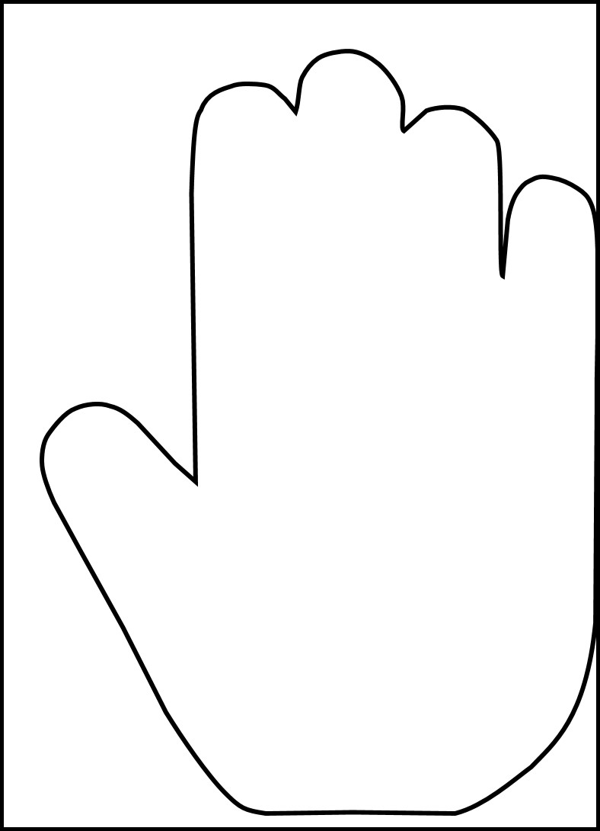

- Now keeping the card folded cut around your hand shape. DO NOT cut the folded edge by your little finger.
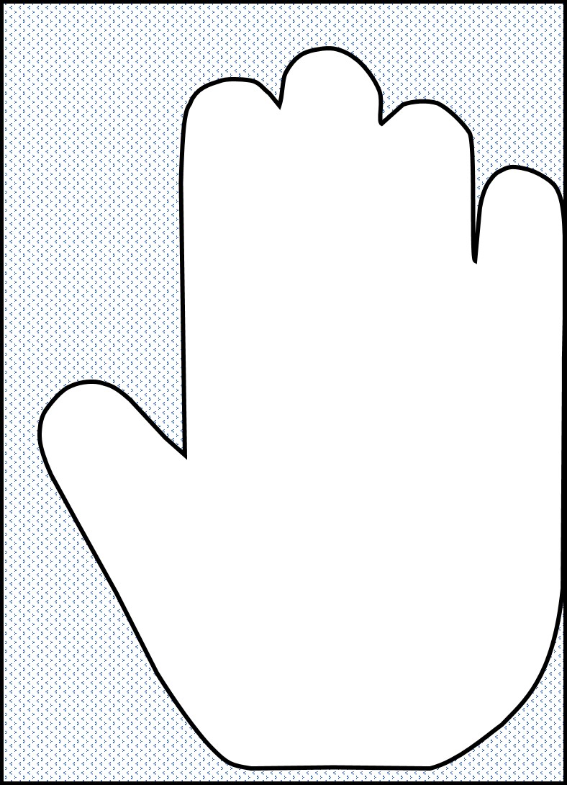

- Now open your card out. The hands should still be joined together along the fold.

- Next, write on the palms of the hands a thank you prayer to Jesus for dying for you. You can copy mine if you like.

- Finally decorate and colour the front and back of your hand cards.

Remember today’s memory verse when you are talking to God in prayer.
For God loved the world so much that he gave his only Son. God gave his Son so that whoever believes in him may not be lost but have eternal life. John 3 v 16

