Feeding 5000 Thousand – Salt Dough fish activity

In this activity you will need:
- 1 cupful of plain flour (about 250g)
- half a cupful of table salt (about 125g)
- half a cupful of water (about 125ml)
- Baking sheet
- Paints
- A clever mum or dad to help you with the cooking and mixing and to adapt the instructions if you need help.

- Firstly, get mum or dad to turn on your oven at its lowest setting.

- Mix the flour and salt in a large bowl. Add the water and stir until it comes together into a ball.

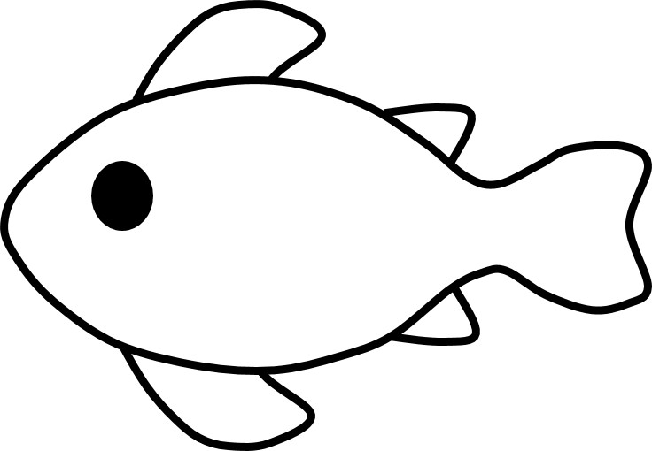
- Transfer the dough to a floured work surface and mould into two fish shapes. You might make more than two fish. Remember to mark a hole in the tail.

- Where you have marked the hole in the fish’s tail, push a pencil through to make a hole.

- Put your finished fish on the baking sheet and bake at the bottom of the oven for 3 hrs or until solid.

- Leave the fish to cool and then paint them.

- Thread a piece of ribbon or string through the tail to hang your fish up.

