Moses and the 10 Plagues – Plague Wheel Craft

In this activity you will need:
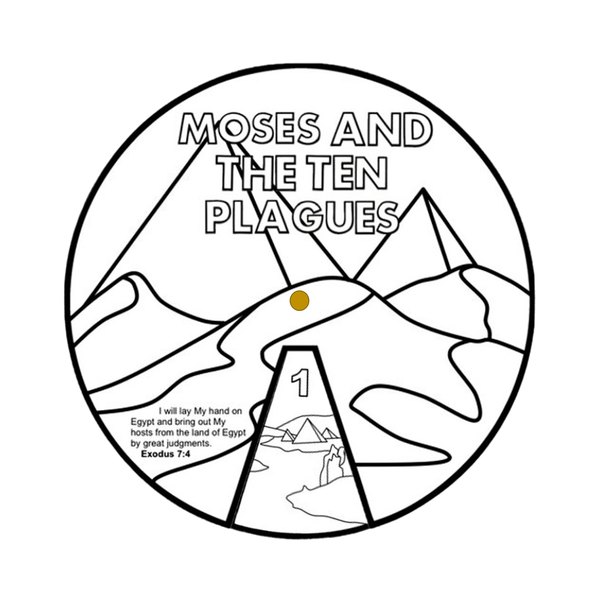
- 2 x A4 pieces of thin card
- Some coloured crayons or pens
- A pair of scissors
- A split pin
- Circle templates
- A clever mum or dad to help you with the cutting out and to adapt the instructions if you haven’t all the materials.

- Firstly, cut out the two circular templates.
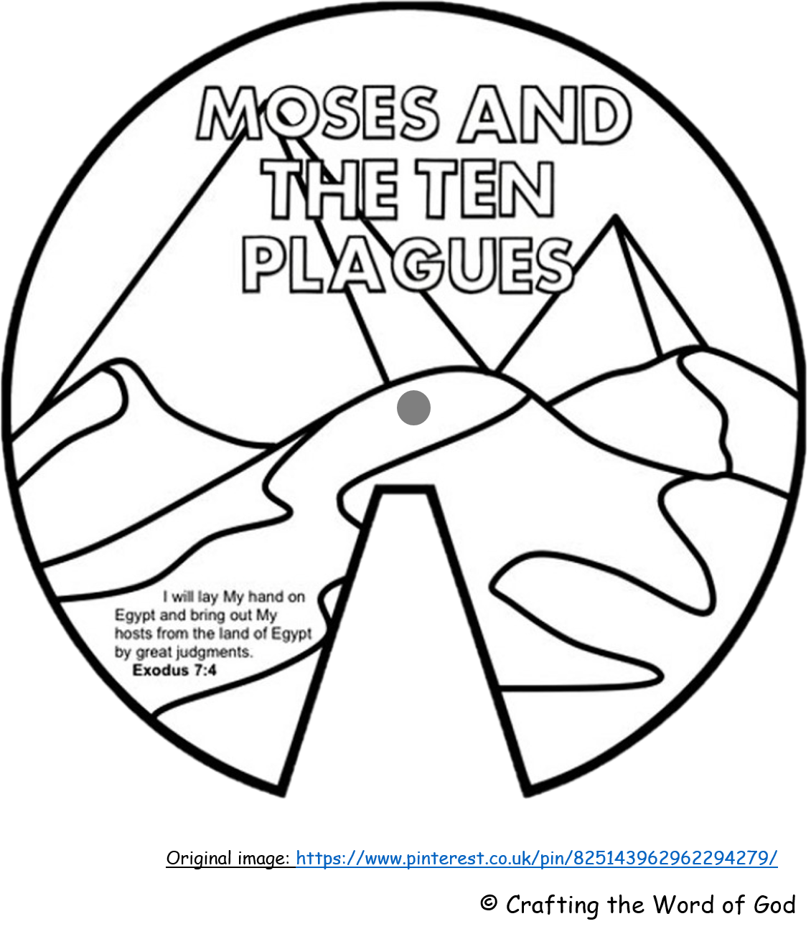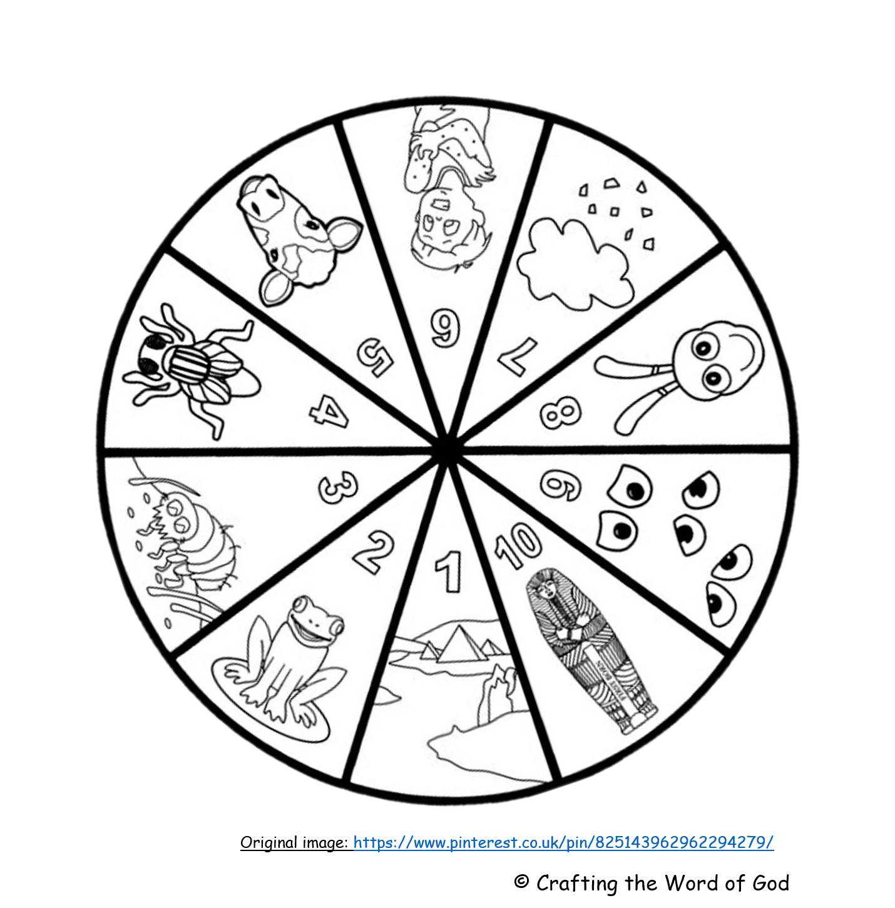
- Now, colour in the 10 segments of the bottom wheel and the title and picture on the top wheel.
- Next, make a small hole through the centre spot of each circle using a pencil.
- Finally push the split pin through the holes to hold the two wheels together. Fold the ends of the pin out behind the bottom circle.

Challenge your friends or family to tell you what each plague was.

