Jesus heals ten Lepers – Shaker craft activity

In this activity you will need:
- Clean empty yoghourt pot or paper cup or toilet roll centre or 400gm tin can (Please check can hasn’t a sharp lip)
- 20gm of rice or Penne or Fusilli or Macaroni pasta
- White paper
- Pair of scissors
- Sellotape
- Colouring pens / crayons / pencils
- A clever mum or dad to help you with the cutting and to adapt the instructions if you need help.
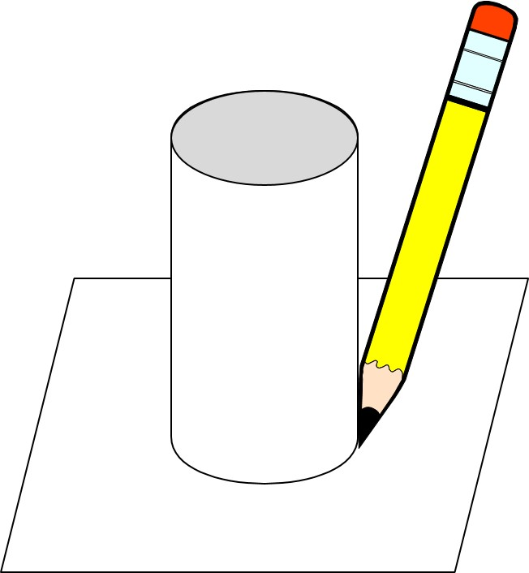
- Firstly, turn your container upside down and put it on your paper. Draw 2 circles using your container as a stencil. (If you are using a toilet roll core you will need 4 circles.)

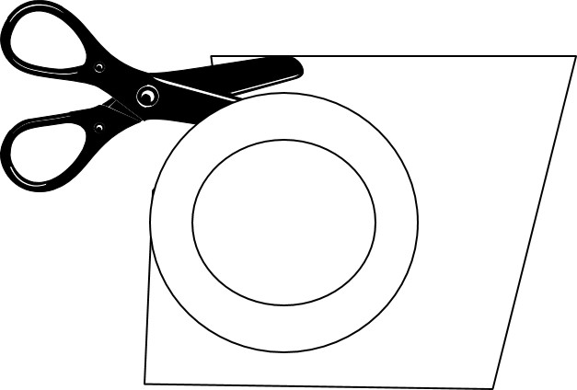
- Cut out the circles but make them about 1cm bigger , so you can fold them over the top of the container.

- If you are using a paper cup, decorate the outside with your colours. (if you are using a can, yoghourt pot or toilet roll you will need to cover it with paper before decorating it.)

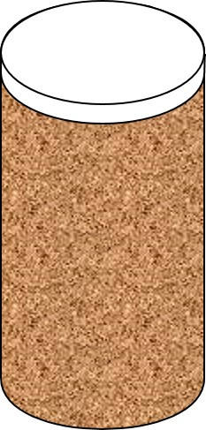

- If you are using a toilet roll core. Take 2 of the circles you cut out and put them both on one end of the roll. Fold the paper over and Sellotape it down to seal the end of the tube.
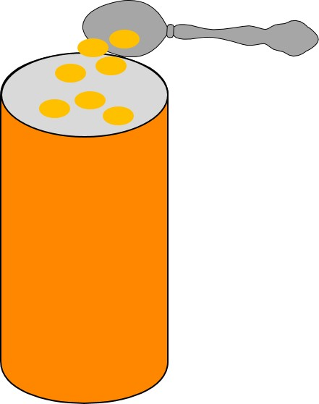

- Put the 20gm of rice or pasta into the tube.

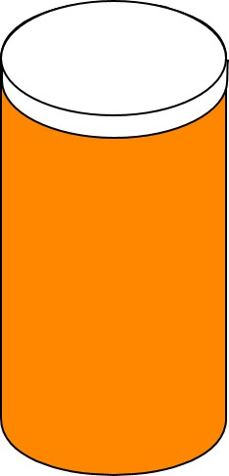
- Take the 2 circles you cut out and put them both on one end of the container. Fold the paper over and Sellotape it down to seal the end of the tube.
You now have a shaker to warn people you are coming.

